Notes and Reflections Journal
Global Change, Communities, & Families in Thailand
May 13 – June 3, 2018

Name: ________________________________

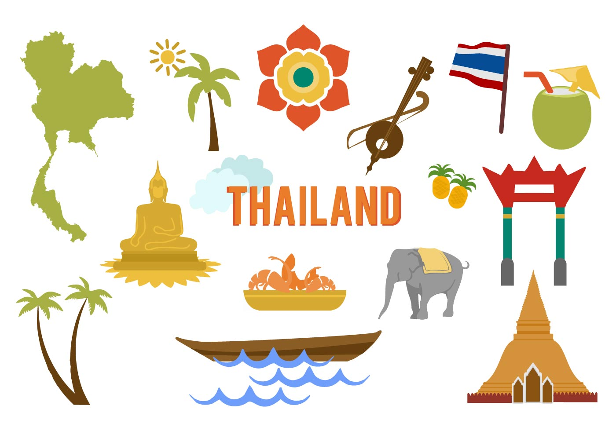
“It is better to travel well than to arrive.”
The Buddha

Adapted for the Thailand Learning Abroad course by Dr. Catherine Solheim, Professor, Family Social Science
This journal was designed for you to reflect on your experiences as you journey in Thailand. The purposes of these writing assignments are:
- Capture your experience in detail so that you can return in the future and remember what you saw, heard, smelled, tasted, felt, and experienced;
- Write your ideas and reflections down will also help you synthesize what you’re learning;
- Integrate what you’ve learned into your knowledge and experience base;
- Contribute to your personal growth through examining and understanding your beliefs, values, and culture; and
- Demonstrate your critical thinking about your experiences and what you’ve learned in this course.

Start your journey here…..

Who are you and how were you shaped as a culture being?

Write down 5-10 words or phrases that help others understand how you see yourself.

Write down a few words or phrases to describe how others tend to describe you.

Identify 2-3 significant events from your life that have helped to define and shape you. In what ways did they impact you?

List 4-6 values that you hold and describe their meanings. For example, if you value family, what does that look like? How does that play out in your life?

How would describe your culture to someone who does not share a similar culture? (Could include dimensions related to customs, beliefs, faith, ethnicity, language(s), foods, holidays, music, art, race, gender, sexual orientation, abilities, education, class, etc.)

Identify the expectations you have for this course and what has shaped them.

Have you traveled internationally? If yes, where have you traveled and what have you learned from those experiences? If no, why are you choosing Thailand as your first travel experience?

Interacting in a New Culture
ODBIE: Observe, Describe, Pause, Interpret, and Evaluate

Spend the most time and effort on these two steps.

Observe: Watch and listen to what is happening without allowing your own thoughts to interpret or evaluate.

Describe: State observable facts. Provide rich detail. Choose words that are non-judgmental.

When you believe you have a good grasp on the situation/phenomenon/interaction, then move to the next step…

Pause: Stop to identify the assumptions from your own framework that may be influencing your thinking about and reactions to what you’re experiencing or observing. Pause to take perspective.

Interpret: Don’t rush to interpret what you’ve seen or experienced. First, ask questions of cultural insiders that can help you understand. Why might this be the case?

Then ask yourself: Why am I frustrated, excited, sad? What is influencing me to think about what I’ve observed in this particular way? What is influencing what I’m observing from a Thai cultural or contextual perspective?

When you have grappled sufficiently to understanding your own and another’s perspectives, you may be able to move to this step. Without sufficient cultural insight, this is a rare occurrence.

Evaluation: You must first understand deeply enough to interpret the situation/phenomenon/interaction. You must recognize that your own values and cultural socialization are influencing how you’re judging the situation. You must consider context – what has influenced this situation/phenomenon/interaction?

Reflection 1: Arrival, First impressions, First Interactions
DAY 1 May 15: Child Safe Workshop, Walking Around Bangkok
DAY 2 May 16: Khan Toke Dinner and Chiang Mai first impressions

DAY I
Describe at least three experiences or observations that were new to you. Use your five senses – taste, touch, smell, sight, sound.

What feelings and thoughts did those experiences evoke for you?

What information did you learn from the Child Safe Workshop that surprised you? What is something you learned that will change your awareness and/or behavior when you travel?

What did you observe in Bangkok that surprised you the most? What are some key differences between Bangkok and your current and/or home location? What are some similarities?

What five Thai words were you able to use today in your interactions with Thai people? In what contexts were the words used? (E.g., transportation, restaurant, hotel, market, village, school etc.)

DAY 2
Describe at least three experiences or observations that were new to you. Use your five senses – taste, touch, smell, sight, sound.

What did you observe and learn about Thai culture from the Khan Toke dinner? What was your favorite part? What challenged you in that experience?

What have you observed about differences between Bangkok and Chiang Mai at this point in time?

What five words were you able to use over the past two days in your interactions with Thai people? In what contexts were the words used? (E.g., transportation, restaurant, hotel, market, etc.)

My first impressions of Thailand are …….

As I write, I am feeling ………

I am looking forward to ………………

***** Please know that if you have any concerns or are anxious about anything, let Acharn Cat or Jory know right away.
Reflection 2: Experiencing Chiang Mai and Stepping into Thai Culture
DAY 3 May 17 Morning: Cooking Class, Wat Suan Dok
DAY 3 May 17 Afternoon: Chiang Dao School, Pha Nok Kok Village

DAY 3 Morning
What did you observe at the market – use your senses (taste, touch, smell, sight, sound).

What surprised you?

What challenged you?

What was the favorite part about the Cooking School? What was your favorite food? Was this a new taste for you? If you had eaten this ‘dish’ in the U.S., how did it taste different or similar?

What did your experience at the Cooking School (including the market visit) teach you about Thai culture? How does this relate to the connection between food and culture (family or ethnic culture) for you? (For example, are there dishes that connect you to your family or your ethnic roots? What about that food holds the memory or tradition – the cooking/baking, the ingredients, the traditions in which they’re eaten, the people connected to it?)

DAY 3 Afternoon
What did you observe in Wat Suan Dok?

What did you learn about Buddhism that added to your understanding of this religious philosophy?

Do you find any similarities between Buddhism and your personal or religious beliefs? In what ways do you connect with Buddhism and/or in what ways is Buddhism connected to Thai culture?

Describe your reaction to our group reflection exercise. What assumptions from your Western framework were influencing your thinking and reactions to today’s experience at the Wat? What new perspectives were you able to take after this process?

What five Thai words were you able to use today in your interactions with Thai people? In what contexts were the words used? (E.g., transportation, restaurant, hotel, market, village, school etc.)

As I write, I am feeling ………

I am looking forward to ………………

***** Please know that if you have any concerns or are anxious about anything, let Acharn Cat or Jory know right away.

Reflection 3: Understanding Cultural Diversity in Thailand
DAY 4 May 18 Morning: Chiang Dao School
DAY 4 May 18 Afternoon: Pha Nok Kook Village

DAY 4 Morning

If someone asked you to describe Chiang Dao School, what would you say? (Engage your senses – what did you see, what did you hear, what was explained to you?) What makes it unique?

How does this school fit into the overall Thai educational system?

What are some things you admire about the school?

What are some of the challenges that this school and the students attending there face?

DAY 4 Afternoon
What stood out to you from our visit to the Pha Nok Kok village? (Engage your five senses)

How is this village changing in today’s globalized environment? What is influencing those changes?

How are the lives of the people who live in this village similar and different than your life?

What did you learn about Hmong-Thai culture during your visit here?

What do you admire about this village and culture?

What five Thai words were you able to use today in your interactions with Thai people? In what contexts were the words used? (E.g., transportation, restaurant, hotel, market, village, school etc.)

As I write, I am feeling ………

I am looking forward to ………………

***** Please know that if you have any concerns or are anxious about anything, let Acharn Cat or Jory know right away.
Reflection 4: Exploring On Your Own
DAY 5 May 19: Free Day in Chiang Mai
DAY 6 May 20: Transit Day to Chiang Rai and Night Market

What did you do on your free day?

What did you learn about Thailand and about yourself during this unstructured time when you were immersed in the culture without guides?

What did you observe and experience at the night market? New sights, sounds, tastes, smells?

What five Thai words were you able to use today in your interactions with Thai people? In what contexts were the words used? (E.g., transportation, restaurant, hotel, market, village, school etc.)

As I write, I am feeling ………

I am looking forward to ………………

***** Please know that if you have any concerns or are anxious about anything, let Acharn Cat or Jory know right away.
Reflection 5: Chiang Rai
DAY 7 May 21: Hill Area Development Foundation
DAY 8 May 22: Huay Kom Nok Village
DAY 9 May 23: Hmong Culture Club

DAY 7 Hill Area Development Foundation

Briefly describe the work of the HADF (program focus, populations served, goals, etc.)

How does intersectionality manifest itself in their work with families and communities?

Which elements of social justice are present and how are they embodied in HADF’s work?

Describe your engagement with the indigenous foods that you prepared/ate. (Use your senses!)

What five Thai words were you able to use today in your interactions with Thai people? In what contexts were the words used? (E.g., transportation, restaurant, hotel, market, village, school etc.)

DAY 8 Huay Kom Nok Karen Village

What similarities and differences did you observe/experience in this Karen village compared to the Pha Nok Kok Hmong village?

How will you describe this village and the people you met to others back home? What will you choose to focus on and why? Reflect and share why those particular ideas stand out for you.

Use the Human Ecology nested model to describe the Karen way of life that was shared by our cultural informant.

What five Thai words were you able to use today in your interactions with Thai people? In what contexts were the words used? (E.g., transportation, restaurant, hotel, market, village, school etc.)

As I write, I am feeling ………..

***** Please know that if you have any concerns or are anxious about anything, let Acharn Cat or Jory know right away.

DAY 9 Hmong Student Club

What did you learn about Hmong Thai culture?

What did you learn about higher education and students’ college experiences?

What five Thai or Hmong words were you able to use today in your interactions with Hmong Thai people? In what contexts were the words used? (E.g., transportation, restaurant, hotel, market, village, school etc.)

Journal Turn-In
DAY 10 May 24: Transit to Chiang Khong

Please turn in your journal by 10:00 p.m. on May 24 (Thursday). We will use this space to give you feedback and share reactions to what you’re learning. If there is something particular you’d like to call our attention to or explain, please add that here.

DAY 11 May 25: Work session in Chiang Khong
No journal entry required.

DAY 12: May 26 Free Day to Explore Chiang Khong
No journal entry required.

Reflection 6: Chiang Khong
DAY 13 May 27: Mekong Child Rights Protection Center
DAY 14 May 28: Hmong Village Visit

DAY 13: Mekong Child Rights Protection Center

What vulnerabilities do rural children in northern Thailand experience? What is influencing their vulnerabilities?

How did you feel when learning about these vulnerabilities? How did you engage your privilege as an American?

What are some of the ways that CRPC ‘empowers’ vulnerable children to protect them from human trafficking, drug addiction, etc.?

What was your favorite part of the day at CRPC? Why was it meaningful?

What five Thai or Hmong words were you able to use today in your interactions with Hmong Thai people? In what contexts were the words used? (E.g., transportation, restaurant, hotel, market, village, school etc.)

As I write, I am feeling ………..

***** Please know that if you have any concerns or are anxious about anything, let Acharn Cat or Jory know right away.
DAY 14: Hmong Village

How did you connect with the students despite language barriers?

How was cultural pride displayed in our activities or the teachers’ or students’ descriptions of their lives?

How does privilege or lack thereof ‘show-up’ in this school and the school in Chiang Dao?

How does being at this school change or influence your perspective of education?

What five Thai or Hmong words were you able to use today in your interactions with Hmong Thai people? In what contexts were the words used? (E.g., transportation, restaurant, hotel, market, village, school etc.)

As I write, I’m feeling ……..

***** Please know that if you have any concerns or are anxious about anything, let Acharn Cat or Jory know right away.

Reflection 7: Chiang Khong
DAY 15 May 29: Visit to Laos
DAY 16 May 30: Mekong School

DAY 15: Laos

Did you observe or experience any differences between Laos and Thailand? Share a few of your observations/experiences. What did you notice first? Why do you think that was most readily apparent?

Discuss how you think these borderlands through the Mekong River runs facilitate or are impacted by globalization. What did you observe or experience that suggests this is the case?

Describe the work of the NGO we visited (program focus, values, target audience, goals).

What did you appreciate about their work?

Were you able to use any of your Thai words in Laos? If yes, which ones? What was that experience like?
DAY 16 Mekong School

Describe the work of the Mekong School using the human ecology model.

On what principles of social justice is their work organized? How do they play out in their efforts?

What barriers does the Mekong School face in their efforts to seek social justice?

Discuss any forces of globalization you see evident in the issues that the Mekong School is addressing?

What did you observe or experience about how this organization operates relationally or organizationally? What is the ‘glue’ that holds them together? How does this relate to a generalized Thai worldviews?

What five Thai or Hmong words were you able to use today in your interactions with Hmong Thai people? In what contexts were the words used? (E.g., transportation, restaurant, hotel, market, village, school etc.)

Reflection 7: Synthesis
Reflections on your time in Thailand

Look back at the expectations you wrote down on page 3 before you left the U.S. Which ones were accurate? Which ones were not? What did you experience and learn that were not included in your pre-departure expectations?

What are 3 stories/experiences that stand out for you? (Describe briefly or refer back to your description in this journal)

Why were they meaningful?

How did you change, grow, develop, or mature through this time in Thailand? What have you learned about yourself?

How do you think you might you use what you’ve learned about Thailand and/or about yourself in the future?

What advice would you give future students about this course?

What suggestions do you have to improve the learning experiences in this course?

Write a brief description of the focus you are imagining for your digital story. What might be the primary theme(s)? How will you communicate what you learned through words, images, sounds?

Additional Page for Notes

Additional Page for Notes

Additional Page for Notes

Additional Page for Notes

