Notes and Reflections Journal
Global Change, Communities, & Families in Thailand
May 12 – June 2, 2019

Name: ________________________________

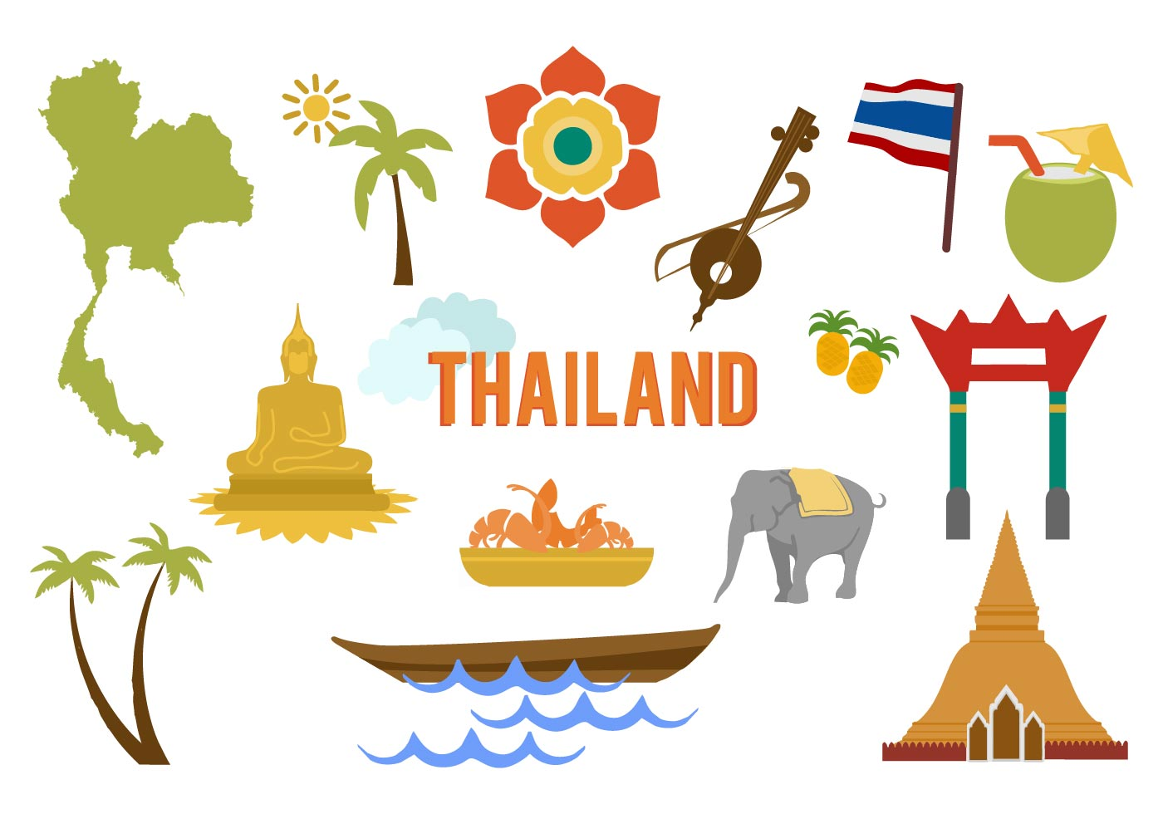
“It is better to travel well than to arrive.”
The Buddha

Adapted for the Thailand Learning Abroad course by Dr. Catherine Solheim, Professor, Family Social Science
This journal was designed for you to reflect on your experiences as you journey in Thailand. The purposes of these writing assignments are:
- Capture your experience in detail so that you can return in the future and remember what you saw, heard, smelled, tasted, felt, and experienced;
- Write your ideas and reflections down will also help you synthesize what you’re learning;
- Integrate what you’ve learned into your knowledge and experience base;
- Contribute to your personal growth through examining and understanding your beliefs, values, and culture; and
- Demonstrate your critical thinking about your experiences and what you’ve learned in this course.

Start your journey here…..

Who are you and how were you shaped as a culture being?

Write down 5-10 words or phrases that help others understand how you see yourself.

Write down a few words or phrases to describe how others tend to describe you.

Identify 2-3 significant events from your life that have helped to define and shape you. In what ways did they impact you?

List 4-6 values that you hold and describe their meanings. For example, if you value family, what does that look like? How does that play out in your life?

How would describe your culture to someone who does not share a similar culture? (Could include dimensions related to customs, beliefs, faith, ethnicity, language(s), foods, holidays, music, art, race, gender, sexual orientation, abilities, education, class, etc.)

Identify the expectations you have for this course and what has shaped them.

Have you traveled internationally? If yes, where have you traveled and what have you learned from those experiences? If no, why are you choosing Thailand as your first travel experience?

Interacting in a New Culture
ODPIE: Observe, Describe, Pause, Interpret, and Evaluate

Spend the most time and effort on these two steps.

Observe: Watch and listen to what is happening without allowing your own thoughts to interpret or evaluate.

Describe: State observable facts. Provide rich detail. Choose words that are non-judgmental.

When you believe you have a good grasp on the situation/phenomenon/interaction, then move to the next step…

Pause: Stop to identify the assumptions from your own framework that may be influencing your thinking about and reactions to what you’re experiencing or observing. Pause to take perspective.

Interpret: Don’t rush to interpret what you’ve seen or experienced. First, ask questions of cultural insiders that can help you understand. Why might this be the case?

Then ask yourself: Why am I frustrated, excited, sad? What is influencing me to think about what I’ve observed in this particular way? What is influencing what I’m observing from a Thai cultural or contextual perspective?

When you have grappled sufficiently to understanding your own and another’s perspectives, you MAY be able to move to this step. Without sufficient cultural insight, this is a rare occurrence.

Evaluation: You must first understand deeply enough to interpret the situation/phenomenon/interaction. You must recognize that your own values and cultural socialization are influencing how you’re judging the situation. You must consider context – what has influenced this situation/phenomenon/interaction?

Reflection 1: Arrival, First impressions, First Interactions

Day 1 May 14: Child Safe Workshop, Chiang Mai first impressions, Khan Toke Welcome Dinner
Day 2 May 15: Visit to local market, Thai Cooking School, Buddhism lecture at Wat Suan Dok

Day I May 14: Child Safe Workshop, Khan Toke Welcome Dinner

Describe your very first impressions of Thailand. Use your five senses – taste, touch, smell, sight, sound.

What information did you learn from the Child Safe Workshop that surprised you? What is something you learned that will change your awareness and/or behavior when you travel?

What did you observe and learn about Thai culture from the Khan Toke dinner? What was your favorite part? What challenged you in that experience?

Day 2 May 15: Local market, Cooking School, Buddhism lecture

What did you observe at the market? Use your senses (taste, touch, smell, sight, sound).

What surprised or seemed strange to you? What basis of comparison did you use in your evaluation of the market experience?

What was the favorite part about the Cooking School? What was your favorite food? Was this a new taste for you? If you had eaten this ‘dish’ in the U.S., how did it taste different or similar?

What did your experience at the Cooking School (including the market visit) teach you about Thai culture? How does this relate to the connection between food and culture (family or ethnic culture) for you? (For example, are there dishes that connect you to your family or your ethnic roots? What about that food holds the memory or tradition – the cooking/baking, the ingredients, the traditions in which they’re eaten, the people connected to it?)

What did you observe in Wat Suan Dok?

What did you learn about Buddhism that added to your understanding of this religious philosophy?

Do you find any similarities between Buddhism and your personal or religious beliefs? In what ways do you connect with Buddhism and/or in what ways is Buddhism connected to Thai culture?

Do you find any similarities between Buddhism and your personal or religious beliefs? In what ways do you connect with Buddhism and/or in what ways is Buddhism connected to Thai culture?

What have you observed in your two days in Chiang Mai that surprised you the most? What are some key differences between Chiang Mai and your current and/or home location? What are some similarities?

What five Thai words were you able to use these past two days in your interactions with Thai people? In what contexts were the words used?

My first impressions of Thailand are …….

As I write, I am feeling ………

I am looking forward to ………………

***** Please know that if you have any concerns or are anxious about anything, let Acharn Cat or know right away.
Reflection 2: Understanding Different Social Locations in Thailand

Day 4 May 17 Morning: Chiang Dao School, Afternoon: Pha Nok Kok Village

NOTE: Group 1 Blog Post Due Friday May 17 by 10:00 pm

Day 4 May 17 Morning at the Chiang Dao School

If someone asked you to describe Chiang Dao School, what would you say? (Engage your senses – what did you see, what did you hear, what was explained to you?) What makes it unique?

How does this school fit into the overall Thai educational system?

What are some things you admire about the school?

What are some of the challenges that this school and the students attending there face?

What cultural strengths did you observe in these students and how is the school working to build them?

Day 4 May 17: Afternoon at the Pha Nok Kok Village

What stood out to you from our visit to the Pha Nok Kok village? (Engage your five senses)

How is this village changing in today’s globalized environment? What is influencing those changes?

How are the lives of the people who live in this village similar and different than your life?

What did you learn about Hmong-Thai culture during your visit here?

What five Thai words were you able to use today in your interactions with Thai and Hmong-Thai people? In what contexts were the words used?

As I write, I am feeling ………

I am looking forward to ………………

***** Please know that if you have any concerns or are anxious about anything, let Acharn Cat know right away.
Reflection 3: Life in a Thai Village

Day 5 May 18: Mae Kampong Village Homestay

NOTE: JOURNAL TURN-IN #1 before leaving for dinner on Sun, May 19th

Day 5 May 18: Mae Kampong Village

What were your first impressions of the home in which you stayed? Describe how it looked – structure, furnishings, rooms, materials, layout, etc. How does the home environment connect with the natural environment?

What did you initially worry about when you entered your host’s home? Be honest. The living arrangements in rural Thai homes are quite different than the ones we’re used to! Dig deep and identify your feelings. Then discuss how you dealt with those feelings. If you were uncomfortable, how were you able to reframe your situation so you were more comfortable? Were you able to think about why you were uncomfortable? Did you consider how the living conditions were normal for your host family and how they might be uncomfortable in your home? How did you move into a learning mode and take a new perspective on housing and all things related (beds/mats, mosquito nets, showers, toilets, kitchens, etc.

Were you able to communicate with your host family? If yes, how did you do that? If not, how did that feel and how were you able to understand what you needed to do?

Describe the village and its people. What are its strengths? What challenges do they face?

What five Thai words were you able to use today in your interactions with Thai people? In what contexts were the words used? (E.g., transportation, restaurant, hotel, market, village, school etc.)

As I write, I am feeling ………

I am looking forward to ………………

**** Please know that if you have any concerns or are anxious about anything, let Acharn Cat know right away.

Reflection 4: Ethnic Diversity in Northern Thailand

DAY 7 May 20: Hill Area Community and Development Foundation;
DAY 8 May 21: Karen Village;
DAY 9 May 22: Chiang Rai Rajabpat Hmong Student Club

Day 7 May 20: Hill Area Community and Development Foundation

Briefly describe the work of the HADF (program focus, populations served, goals, etc.)

How does intersectionality manifest itself in their work with families and communities?

Which elements of social justice are present and how are they embodied in HADF’s work?

Describe the indigenous foods that you prepared/ate and your reactions. (Use your senses!)

What five Thai words were you able to use today in your interactions with Thai people? In what contexts were the words used?

Day 8 May 21: Huay Kom Nok Karen Village

What similarities and differences did you observe/experience in this Karen village compared to the Pha Nok Kok Hmong village?

How will you describe this village and the people you met to others back home? What will you choose to focus on and why? Reflect and share why those particular ideas stand out for you.

Use the Human Ecology nested model to describe the Karen way of life that was shared by our cultural informant (family, human built, socio-cultural, and natural/physical environments)

What five Thai words were you able to use today in your interactions with Thai people? In what contexts were the words used?

Day 9 May 22: CRRU Hmong Student Club

What did you learn about Hmong Thai culture?

What did you learn about higher education and students’ college experiences?

Which of the activities did you enjoy the most and why?

What five Thai or Hmong words were you able to use today in your interactions with Hmong Thai people? In what contexts were the words used?

Reflection 5: Impressions of Chiang Khong and the Mekong

Day 10 May 23: White Temple and arrival in Chiang Khong
Day 11 May 24: Group project work day
Day 12 May 25: Free day in Chiang Khong

NOTE: Group 2 Blog Post due Wednesday May 23 10:00 pm

NOTE: JOURNAL TURN-IN #2 before leaving for dinner on Friday, May 24

Day 10 May 23: White Temple and transit to Chiang Khong

What were your impressions of the White Temple? What were the ideas that the artist was trying to convey?

What were your first impressions of Chiang Khong and the Mekong River? What did you know about the Mekong River before arriving here?

***** Please know that if you have any concerns or are anxious about anything, let Acharn Cat know right away.

Day 11 May 24: Group Project Work Day

Use this page to take notes, draft an outline, etc. for your group project work. I will look for some evidence of your involvement in the group project, so please include some information!

Day 12 May 25: Free day in Chiang Khong

What did you do on your free day?

What did you learn about Thailand and about yourself during this time when you were immersed in local Thai culture without structure and guides?

What five Thai words were you able to use today in your interactions with Thai people? In what contexts were the words used?

Reflection 6: Cultural Diversity and Social Locations

DAY 13 May 26: Sunflower House
DAY 14 May 27: Tung Na Noy Hmong Village
DAY 14 May 28: Daauw Village in Laos

Day 13 May 26 Sunflower House

What vulnerabilities do rural children in northern Thailand experience? What is influencing their vulnerabilities?

How did you feel when learning about these vulnerabilities? How did you engage your privilege as an American?

What are some of the ways that the Sunflower House ‘empowers’ vulnerable children to protect them from human trafficking, drug addiction, etc.?

What was your favorite part of the day at the Sunflower House? Why was it meaningful?

Day 14 May 27: Hmong Village Tung Na Noy

How did you connect with the students at the Tung Na Noy village school despite language barriers?

How was cultural pride displayed in our activities or the teachers’ or students’ descriptions of their lives?

How does privilege or lack thereof ‘show-up’ in this school and the school in Chiang Dao?

How does being at this school change or influence your perspective of education?

What five Thai or Hmong words were you able to use today in your interactions with Hmong Thai people? In what contexts were the words used?

Day 15 May 28: Daauw Village Laos

Did you observe or experience any differences between Laos and Thailand? Share a few of your observations/experiences. What did you notice first? Why do you think that was most readily apparent?

Discuss how you think these borderlands through the Mekong River runs facilitate or are impacted by globalization. What did you observe or experience that suggests this is the case?

Describe the work of Daauw Village (program focus, values, target audience, goals).

What did you appreciate about their work?

Were you able to use any of your Thai words in Laos? If yes, which ones? What was that experience like?

REFLECTION 7: Environmental Issues in Northern Thailand

DAY 16 May 19: Mekong School

NOTE: Blog Post Group #3 Due by 10:00 pm

Day 16 May 29: Mekong School

Describe the work of the Mekong School using the human ecology model.

On what principles of social justice is their work organized? How do they play out in their efforts?

What barriers does the Mekong School face in their efforts to seek social justice?

Discuss any forces of globalization you see evident in the issues that the Mekong School is addressing?

What did you observe or experience about how this organization operates relationally or organizationally? What is the ‘glue’ that holds them together? How does this relate to a generalized Thai worldviews?

What five Thai words were you able to use today in your interactions with Thai people? In what contexts were the words used?

Reflection 7: Synthesis – Reflections on What Thailand Has Taught You

NOTE: FINAL JOURNAL TURN-IN ON FRIDAY, MAY 31 BY 6:00 PM

Look back at the expectations you wrote down on page 3 before you left the U.S. Which ones were accurate? Which ones were not? What did you experience and learn that were not included in your pre-departure expectations?

Share three stories/experiences that stand out for you? Why were they meaningful? (Describe briefly or refer back to your description in this journal)

How did you change, grow, develop, or mature through this time in Thailand? What have you learned about yourself?

How do you think you might you use what you’ve learned about Thailand and/or about yourself in the future?

What advice would you give future students about this course?

What suggestions do you have to improve the learning experiences in this course?

Write a brief description of the focus you are imagining for your digital story. What might be the primary theme(s)? How will you communicate what you learned through words, images, sounds?

I will use the following space to give you feedback on your participation in this course and your overall reflections. If there were something particular you’d like to call my attention to or explain, please add that here.

Additional Page for Notes

Additional Page for Notes

Additional Page for Notes

Additional Page for Notes

Additional Page for Notes

Additional Page for Notes

