Notes and Reflections Journal
Global Change, Communities, & Families in Thailand
May 14-29, 2022

Name: ________________________________

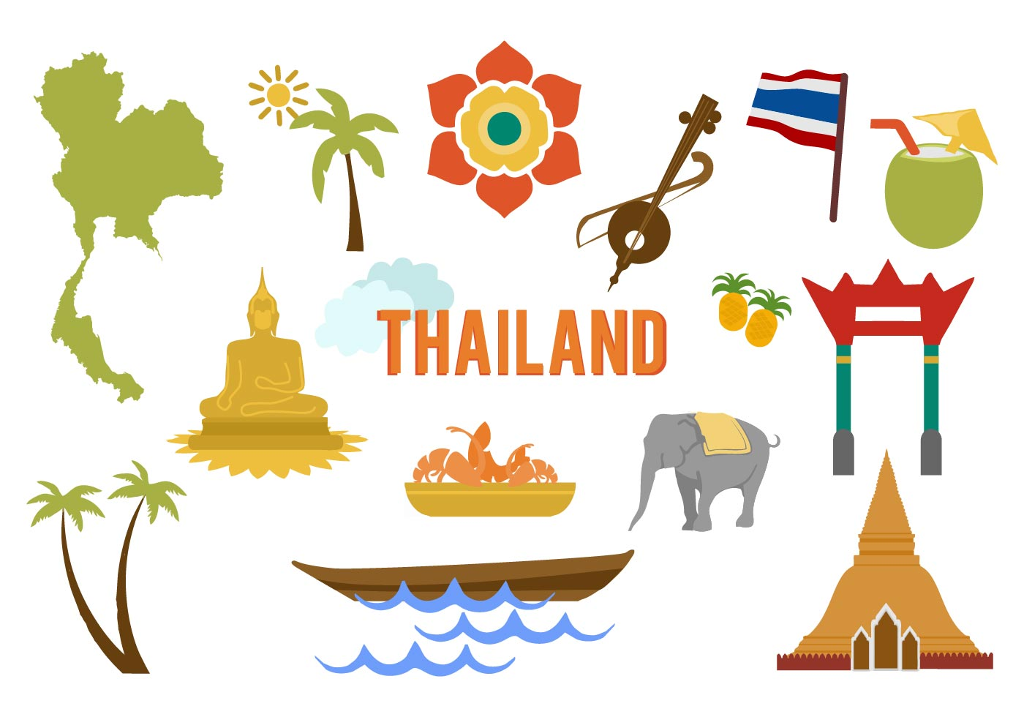
“It is better to travel well than to arrive.”
The Buddha

Instructor: Dr. Catherine Solheim, Professor, Family Social Science
csolheim@umn.edu
Use this journal to reflect on your experiences as you journey in Thailand. The purposes of these writing assignments are to:
- Capture your experience in detail so that you can return in the future and remember what you saw, heard, smelled, tasted, felt, and experienced;
- Help you synthesize what you’re learning by taking time to reflect in real-time;
- Integrate what you’ve learned into your knowledge and experience base;
- Contribute to your personal growth through examining and understanding your beliefs, values, and culture; and
- Demonstrate your ability to think critically and respectfully about your experiences;
- Document what you learn in this course.

Start your journey here.

Who are you and what shaped you as a culture being?

Write down 5-10 words or phrases that help others understand how you see yourself.

Write down a few words or phrases to describe how others tend to describe you.

Identify 2-3 significant events from your life that have helped to define and shape you. In what ways did they influence you?

List 4-6 values that you hold and describe their meanings. For example, if you value family, what does that look like? How does that play out in your life?

How would describe your culture to someone who does not share a similar culture? (Could include dimensions related to customs, beliefs, faith, ethnicity, language(s), foods, holidays, music, art, race, gender, sexual orientation, abilities, education, class, etc.)

Identify the expectations you have for this course and what has shaped them.

Have you traveled internationally? If yes, where have you traveled and what have you learned from those experiences? If no, why are you choosing Thailand as your first travel experience?

Interacting in a New Culture
ODPIE: Observe, Describe, Pause, Interpret, and Evaluate

Spend the most time and effort on these two steps.

Observe: Watch and listen to what is happening without allowing your own thoughts to interpret or evaluate.

Describe: State observable facts. Provide rich detail. Choose non-judgmental words.

When you believe you have a good grasp on the situation/phenomenon/interaction, then move to the next step…

Pause: Stop to identify the assumptions from your own framework that may be influencing your thinking about and reactions to what you’re experiencing or observing. Pause to take perspective.

Interpret: Don’t rush to interpret what you’ve seen or experienced. First, ask questions of cultural insiders that can help you understand. Why might this be the case?

Then ask yourself, why am I frustrated, excited, sad? What is influencing me to think about what I’ve observed in this particular way? Can I consider the Thai or contextual perspective to begin to understand this phenomenon or idea in a different way?

When you have grappled sufficiently to understand your own and another’s perspectives, you MAY be able to move to this step. This takes time and fairly extensive cultural insight.

Evaluation: You must first understand deeply enough to interpret the situation/phenomenon/interaction. You must recognize that your own values and cultural socialization are influencing how you are judging the situation. You must consider context – what has influenced this situation/phenomenon/interaction?

HUMAN ECOLOGY Model

Human Ecology Model: Interdependence of organisms (individuals/families) and the environmental systems with which they interact
Nested model: Reciprocal relationships – interdependence – both influenced by and influence
Families live, work, move in their Human Built Environment (HBE) which is influenced by their Social-Cultural Environment (SCE), and adapt to and draw resources from their Natural Physical-Biological Environment (NPBE).

Family: defined as groups of people who have enduring relationships and who share resources
HBE: elements of physical and biological environments altered by humans (buildings, bridges, homes, roads, etc.)
SCE: relationships, beliefs, language, laws, cultural values and norms, systems (education, political, religious)
NPBE – soil, water, climate
Family Structure: Families have diverse characteristics (Members, Ethnic Origin, Life Stage, Socio-economic status) with combined individual and family attributes (Needs, Values, Goals, Resources)

Principles of Social Justice*

Human Dignity
Dignity of the human person is the ethical foundation of a moral society. The measure of every institution is whether it threatens or enhances the life and dignity of the human person.

Community and the Common Good
All individuals by virtue of their human nature have social needs. Human relationships enable people to meet their needs and provide an important vehicle for change.

Rights and Responsibilities
People have a right and a responsibility to participate in society and to work together toward the common good.

Priority for the Poor and Vulnerable
A basic moral test of any community or society is the way in which the most vulnerable members are faring. In a society characterized by deepening divisions between rich and poor, the needs of those most at risk should be considered a priority.

Participation
All people have a right to participate in the economic, political and cultural life of society. Social justice and human dignity require that all people be assured a minimum level of participation in the community. It is the ultimate injustice for a person or a group to be excluded unfairly.

Dignity of Work and the Rights of Workers
In a marketplace where profit often takes precedence over the dignity and rights of workers, it is important to recognize that the economy must serve the people, not the other way around. If the dignity of work is to be protected, the basic rights of workers must be respected – the right to productive work, to decent and fair wages, to organize and join unions, to private property and to economic initiative.

Solidarity
We are our brothers and sisters keepers. We are one human family, whatever our national, racial, ethnic, economic, and ideological differences.

Stewardship
It is incumbent upon us to recognize and protect the value of all people and all resources on our planet. While rights to personal property are recognized, these rights are not unconditional and are secondary to the best interest of the common good especially in relation to the right of all individuals to meet their basic needs.

Governance/Principle of Subsidiarity
Governance structures in all levels/settings have an imperative to promote human dignity, protect human rights, and build the common good.

Promotion of Peace
In light of the human dignity and worth of all and the ethical imperatives of solidarity and stewardship, we are called to promote peace and non-violence at all levels – within families, communities, society and globally. Peace is the fruit of justice and is dependent upon the respect and cooperation between peoples and nations.

*School of Social Work St. Thomas University; Adapted from U.S. Conference of Catholic Bishops, Office of Social Justice-Archdiocese of St. Paul.

Reflection 1: Arrival, First impressions, First Interactions

Describe your very first impressions of Thailand. Use your five senses – taste, touch, smell, sight, sound.

What was congruent with what you expected? What was different from what you expected?

What did you do during your first day in Bangkok? Describe what you saw, what you ate, what you felt, what you heard. What was your favorite experience and why? What was challenging for you and why?

What Thai words did you hear repeatedly? What words/phrases are you beginning to say?

After my first full day in Thailand:

I am feeling ………

I am looking forward to ………………

***** Please know that if you have any concerns or are anxious about anything, let Acharn Cathy know right away.
Reflection 2: Chiang Rai (White Temple, Hill Tribe Museum, Night Market)

What is your impression of the White Temple? Describe your experience there to capture it in your memory bank.

Describe three things you learned about Thailand’s ethnic minority groups from your visit to the Hill Tribes Museum today. What more do you want to learn about their cultures?

Think about the generation of Hmong people who fled Laos after the war and arrived in the U.S. (Minnesota) to resettle. What were some of the most significant changes they faced in their new homelands? Use the human ecology model to consider the human built environment, the socio-cultural environment, and the natural-physical environment.

What did you experience at the night market? Use your senses to describe tastes, textures, smells, sights, sounds.

What surprised or seemed strange to you? What basis of comparison did you use in your evaluation of the market experience?

Reflection 3: Temples and Black House

What did you notice about the art, colors, symbols and structures of Buddhist temples? What meanings do these hold for the Thai people? (Ask our guide, look them up, etc.)

What did you observe about Thai worshippers at the temples? Describe how they are dressed, what they do at the temple, etc.

How did your experiences today connect with your experience at Wat Promwachirayan in Minnesota? Can you see how Wat Prom is trying to replicate the ‘essence’ of the Thai temples and the Buddhist symbols and traditions in Minnesota? Why do you think this is important for immigrants? Is it just about the religion or do you think it has deeper meaning for Minnesota Thais?

Do you find any similarities between Buddhism and your own beliefs? In what ways do you connect with Buddhism and/or in what ways is Buddhism connected to Thai culture?

Reflection 4: Ethnic Diversity in Northern Thailand
(Akha and Lahu People in Pakasukjai Village in the Maesalong Mountain Region)

Briefly describe the work of the Hill Area Community and Development Foundation
(HADF) (Program focus, populations served, goals, etc.)

How does intersectionality and social justice manifest in their work with families and communities?

Describe in detail the Pakasukjai village and its people. Use the human ecology model to think about the people (ethnicity, relationships, general demographics, etc.), human built environment (houses, roads, stores, schools, etc.), the socio-cultural environment (values, traditions, economics, etc.), and the natural physical environment (mountain/hills, vegetation, climate, pollution, water, etc.).

How would you describe the Akha people’s deep connection to nature and supernature? How do these connections and their traditions manifest in their daily lives

Discuss how agriculture and the natural environment are important to family sustainability and well-being in the Maesalong mountain region. (consider our introduction to production/sales of coffee, fruit, other crops, dependence on the Mekong water shed, forested land, etc,)

Describe the food you ate while in the village and the forest. What foods were ‘local’ or indigenous to that area? Share your reactions. (Use your senses!)

What are the three most important things you learned that you want to remember about your time in this Maesalong Mountain area? Is it something you learned about diversity of families? Is it something you learned about global change? Is it something you learned about communities? Is it something you learned about yourself?
Reflection 4: Anuban Wiengken School

What did you learn about King Rama IX’s Sufficiency Economy Philosophy as it was applied in this school?

How did the curriculum in this school encourage innovation and entrepreneurship? How might this benefit students as they grow up and return to their villages?

What did you observe about the school, teachers and students that was similar and different than what you know from your U.S.-based education experience? Why do you think these differences exist?

As we near the end of our time in Thailand, which Thai words to do you know and use? How has speaking some words in Thai helped you connect with people you have met? Why is learning some basic words in the language of the country you will visit so important when you travel abroad

Reflection 5: Cultural Diversity and Social Locations

Center for Girls
What is the mission and program efforts of the Center for Girls?

What vulnerabilities do women and children in northern Thailand experience? What is influencing their vulnerabilities?

How did you feel when learning about these vulnerabilities? How did you engage your privilege as an American?

What are some of specific ways that the Center for Girls works to prevent abuse and address child welfare issues?

Hmong Village

What strengths and challenges of this community did you learn about during your time in the village?

How did you connect with the people in the village despite language barriers?

Can you connect Hmong peoples’ lives in Thailand to Hmong peoples’ lives in Minnesota? Similarities? Differences? What contributes to those similarities and differences?

Final Reflection/Synthesis: What Thailand Has Taught You

Look back at the expectations you wrote down before you left the U.S. Which ones were accurate? Which ones were not? What did you experience and learn that was not included in your pre-departure expectations?

Share three stories/experiences that stand out for you. In what ways were they meaningful? (Describe briefly or refer back to your description in this journal)

How did you change, grow, develop, or mature through this time in Thailand? What have you learned about yourself?

How do you think you might you use what you learned in Thailand about others and about yourself in the future?

Write a brief description of the focus you are imagining for your digital story. What might be the primary theme(s)? How will you communicate what you learned through words, images, sounds?

I will use the following space to give you feedback on your participation in this course and your overall reflections.

Additional Page for Notes

Additional Page for Notes

Additional Page for Notes

